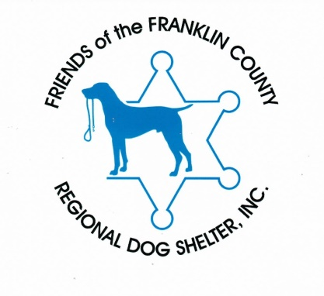

Rabies Clinic April 17, 2021

At the Franklin Country Regional Dog Shelter

12 Sandy Lane, Turners Falls, Ma

Phone (413) 676-9182

From 10:00-12:00

$20.00 per animal

Cash only please to speed up the process!

Masks are required

* All dogs to be on leash
* Cats needs to be in a carrier
* Bring previous rabies certificate for a 3 year vaccine

C:\Program Files (x86)\Microsoft Office\MEDIA\CAGCAT10\j0216724.wmf